Industrial Internship Report on

“Home Automation System”

Prepared by

Shashwat Tripathi

|  |
| --- |
| *Executive Summary* |
| This report provides details of the Industrial Internship provided by upskill Campus and The IoT Academy in collaboration with Industrial Partner UniConverge Technologies Pvt Ltd (UCT).  This internship was focused on a project/problem statement provided by UCT. We had to finish the project including the report in 6 weeks’ time.  My project was (Tell about ur Project)  This internship gave me a very good opportunity to get exposure to Industrial problems and design/implement solution for that. It was an overall great experience to have this internship. |

**TABLE OF CONTENTS**

1 Preface 3

2 Introduction 4

2.1 About UniConverge Technologies Pvt Ltd 4

2.2 About upskill Campus 8

2.3 Objective 9

2.4 Reference 9

2.5 Glossary 10

3 Problem Statement 11

4 Existing and Proposed solution 12

5 Proposed Design/ Model 13

5.1 Interfaces (if applicable) 13

6 Performance Test 14

6.1 Test Plan/ Test Cases 14

6.2 Test Procedure 14

6.3 Performance Outcome 14

7 My learnings 15

8 Future work scope 16

1. **Preface**

* Summary of the whole 6 week’s work

Week-1 Introduction of IOT , its application

Week-2 What is iot devices? , Iot Devices & Platform Rise of Embedded Systems and Iot as Emerging Technologies 2023.

Week-3 Iot Deployment and Challenges , How does cloud computing help iot devices

Week-4 Embedded system training circuit design part 1,2,3 .

Week-5 weekly progress report

Week-6 test

* Internships play a crucial role in career development by providing practical experience, industry exposure, and networking opportunities. They offer valuable hands-on learning, help build a professional network, and enhance job prospects through real-world application of knowledge and skills.
* This project is to develop a home automation system using an Arduino board with Bluetooth being remotely controlled by any Android OS smart phone. As technology is advancing so houses are also getting smarter. Modern houses are gradually shifting from conventional switches to centralized control system, involving remote controlled switches.

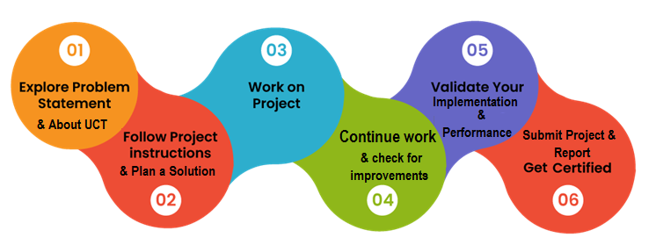

**2** **Introduction**

**2.1 About UniConverge Technologies Pvt Ltd**

A company established in 2013 and working in Digital Transformation domain and providing Industrial solutions with prime focus on sustainability and RoI.

For developing its products and solutions it is leveraging various Cutting Edge Technologies e.g. Internet of Things (IoT), Cyber Security, Cloud computing (AWS, Azure), Machine Learning, Communication Technologies (4G/5G/LoRaWAN), Java Full Stack, Python, Front end etc.



1. UCT IoT Platform

**UCT Insight** is an IOT platform designed for quick deployment of IOT applications on the same time providing valuable “insight” for your process/business. It has been built in Java for backend and ReactJS for Front end. It has support for MySQL and various NoSql Databases.

* It enables device connectivity via industry standard IoT protocols - MQTT, CoAP, HTTP, Modbus TCP, OPC UA
* It supports both cloud and on-premises deployments.

It has features to

• Build Your own dashboard

• Analytics and Reporting

• Alert and Notification

• Integration with third party application(Power BI, SAP, ERP)

• Rule Engine



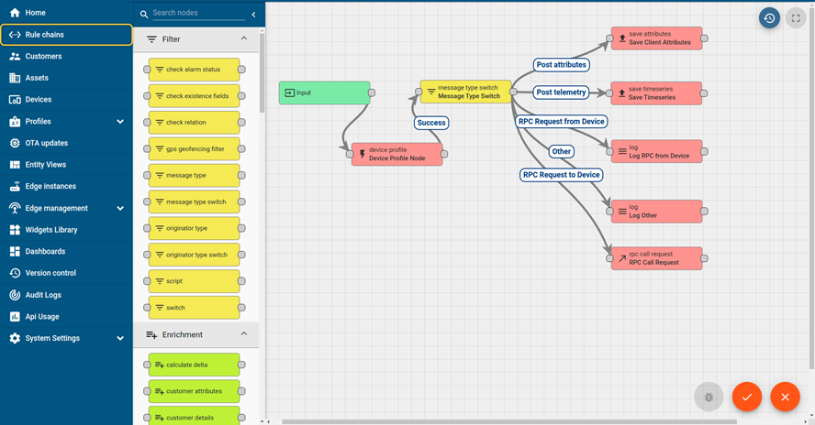

1. **Smart Factory Platform (****)**

Factory watch is a platform for smart factory needs.

It provides Users/ Factory

* with a scalable solution for their Production and asset monitoring
* OEE and predictive maintenance solution scaling up to digital twin for your assets.
* to unleased the true potential of the data that their machines are generating and helps to identify the KPIs and also improve them.
* A modular architecture that allows users to choose the service that they what to start and then can scale to more complex solutions as per their demands.

Its unique SaaS model helps users to save time, cost and money.



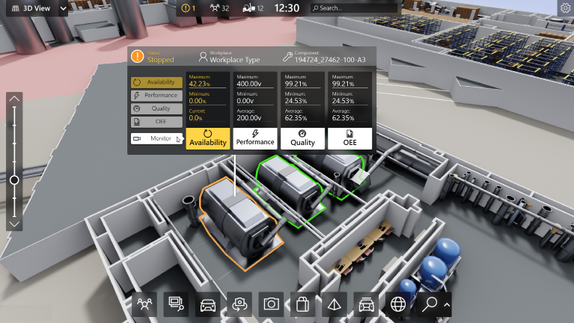

1. 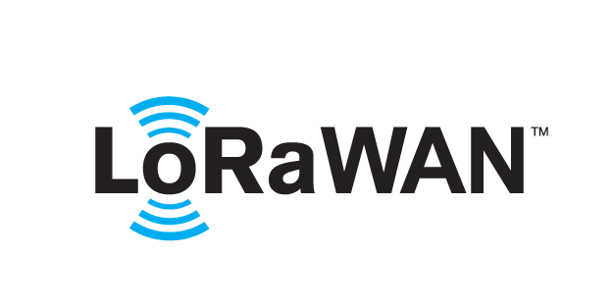 based Solution

UCT is one of the early adopters of LoRAWAN teschnology and providing solution in Agritech, Smart cities, Industrial Monitoring, Smart Street Light, Smart Water/ Gas/ Electricity metering solutions etc.

1. Predictive Maintenance

UCT is providing Industrial Machine health monitoring and Predictive maintenance solution leveraging Embedded system, Industrial IoT and Machine Learning Technologies by finding Remaining useful life time of various Machines used in production process.



## **2.2 About upskill Campus (USC)**

skill Campus along with The IoT Academy and in association with Uniconverge technologies has facilitated the smooth execution of the complete internship process.

USC is a career development platform that delivers **personalized executive coaching** in a more affordable, scalable and measurable way.

## 

## **2.3 The IoT Academy**

The IoT academy is EdTech Division of UCT that is running long executive certification programs in collaboration with EICT Academy, IITK, IITR and IITG in multiple domains.

## **2.4 Objectives of this Internship program**

The objective for this internship program was to

 ☛ get practical experience of working in the industry.

 ☛ to solve real world problems.

 ☛ to have improved job prospects.

 ☛ to have Improved understanding of our field and its applications.

 ☛ to have Personal growth like better communication and problem solving.

## **Reference**

[1] Md. Nasfikur R. Khan, Sarmila Yesmin, “Improving controlling system of a finger simulator”, AsianJournal of Engineering and Technology, Vol 5 (4), August 2017. pp. 113-118.

[2] Md. Rakib Hasan, Md. Nasfikur R. Khan, “Designing A Home Automation System by Using RFReceiver”, International Journal of Advance Research and Innovative Ideas in Education, Vol 3 (4),June 2017. pp. 2318 - 2322.

[3] Md. Faijul Haque, Sabrina Hossain, Ayesha Siddika and Md. Nasfikur R. Khan, "Smart HomeAutomation System based on Environmental Monitoring System," National Conference on Electronicsand ICT, Dhaka, 2017, pp. 1-4.

[4] All about Circuits (2003 2012: N.G.) [Online] http://www.allaboutcircuits.com/vol_3/chpt_3/4.html[23/01/14 .

# **3 Problem Statement**

The current state of home automation systems lacks a comprehensive and user-friendly solution that seamlessly integrates various devices and appliances, providing homeowners with a centralized control system to enhance convenience, energy efficiency, and security.

# **Existing and Proposed solution**

**Existing solution**

eGlu is an affordable and comprehensive Smart Home Solution for your safety, security and convenience. All modules communicate using US & India Patented Low Power Radio Frequency Communication System Indian Frequency (865-867MHz)

HUB Pro v ,HUB ,Door Sensor, Motion Sensor ,In-wall Dual Switch , In-Wall Dual Dimmer RGB LED Controller, IR Controller these are

**Proposed solution**

* Unified Home Automation Platforms
* Voice Control and Natural Language Processing
* Advanced Energy Management Systems
* Enhanced Security and Privacy Features
* Artificial Intelligence (AI) and Machine Learning (ML) Integration
* Integration with Internet of Things (IoT) Ecosystem
* Home automation systems Augmented Reality (AR) and Virtual Reality (VR) Applications

## **Code submission (Github link) : https://github.com/Shashwat8127/Home-Automation/blob/main/sketch_jul15b.ino**

**4.2 Report submission (Github link) :**

1. **Proposed Design/ Model**

This code is an Arduino sketch that controls appliances (such as lights, fans, and locks) based on commands received over Ethernet and sends temperature and humidity data from a DHT sensor to a server via HTTP POST requests. Here's a breakdown of the code:

1. The necessary libraries are included: **SPI**, **Ethernet**, **Adafruit_Sensor**, and **DHT**.
2. Constants are defined for the relay pins and DHT sensor pin.
3. MAC and IP addresses are defined for Ethernet communication.
4. An Ethernet client object is created.
5. A DHT object is created, specifying the DHT sensor pin and type (DHT11).
6. The **sendRequest** function is defined to send an HTTP POST request to the server.
7. The **readSensorData** function reads temperature and humidity data from the DHT sensor and returns it as a string.
8. The **controlAppliances** function controls the appliances based on the received command.
9. In the **setup** function:
   * The relay pins are initialized as outputs.
   * The Ethernet connection is started with the specified MAC and IP addresses.
   * The DHT sensor is initialized.
10. In the **loop** function:
    * If the client is connected, it reads a command from the server and trims any leading/trailing whitespace.
    * If the client is not connected, it generates data from the DHT sensor and creates an HTTP POST request with the data.
    * The request is sent to the server using the **sendRequest** function.
    * A delay of 5 seconds is added before the next iteration.

# **6 Performance Test**

This is very important part and defines why this work is meant of Real industries, instead of being just academic project.

Here we need to first find the constraints.

How those constraints were taken care in your design?

What were test results around those constraints?

Constraints can be e.g. memory, MIPS (speed, operations per second), accuracy, durability, power consumption etc.

In case you could not test them, but still you should mention how identified constraints can impact your design, and what are recommendations to handle them.

## **6.1 Test Plan/ Test Cases**

The code uses the Arduino framework and follows a typical setup and loop structure. In the **setup()** function, the relay pins, Ethernet connection, DHT sensor, and Serial communication are initialized.

In the **loop()** function, there are two main parts. First, it checks if there is any incoming command from the Serial Monitor. If a command is received, it trims the command and passes it to the **controlAppliances()** function, which controls the appliances based on the command.

If there is no incoming command, the code generates sensor data using the DHT sensor and creates an HTTP POST request string. The request includes the sensor data and is sent to the server using the **sendRequest()** function.

After each iteration of the **loop()** function, there is a delay of 5 seconds (5000 milliseconds) before the next iteration begins.

## **6.2 Test Procedure**

1. Upload the code to your Arduino board using the Arduino IDE or your preferred method.
2. Open the Serial Monitor in the Arduino IDE (or any serial communication program) to send commands to the Arduino board.
3. Check the code and note the following details:
   * The relay pins used for controlling the appliances (**RELAY_PIN_1**, **RELAY_PIN_2**, **RELAY_PIN_3**).
   * The DHT sensor pin (**DHT_PIN**).
   * The MAC and IP addresses defined (**mac**, **ip**, **server**).
4. Verify the wiring connections:
   * Ensure that the relay module is connected to the correct relay pins defined in the code.
   * Connect the DHT sensor to the specified pin (**DHT_PIN**).
   * Confirm that the Ethernet shield is properly connected, including the MAC and IP addresses.
5. Power on the Arduino board and connected devices.
6. In the Serial Monitor, enter the following commands one at a time and observe the corresponding actions:
   * **light_on**: This should turn on the light controlled by **RELAY_PIN_1**.
   * **light_off**: This should turn off the light.
   * **fan_on**: This should turn on the fan controlled by **RELAY_PIN_2**.
   * **fan_off**: This should turn off the fan.
   * **lock**: This should lock the device controlled by **RELAY_PIN_3**.
   * **unlock**: This should unlock the device.

Observe the behavior of the controlled appliances as you send these commands.

1. Verify the sensor data transmission:
   * Monitor the Serial Monitor for any error messages related to the DHT sensor. If the sensor data is successfully read, it should display the temperature and humidity values.
   * Check the server specified in the code (IP address: 192.168.1.100) to see if the sensor data is received. Monitor the server logs or any designated endpoint where the data is expected to be sent.
2. Repeat the commands and observe the behavior multiple times to ensure consistent functionality.

## **Performance Outcome**

The output in this code is not directly displayed on a screen or output device. Instead, the code is designed to control appliances and send sensor data to a server using an Ethernet connection. The output of this code is not directly visible but can be observed through the behavior of the controlled appliances or by checking the server where the sensor data is being sent. The code does not have any specific output for debugging or logging purposes.

1. **My learnings**

**Definition and Components of Home Automation:** Explanation of home automation systems and their components, such as smart devices, sensors, controllers, and communication protocols.

**Benefits of Home Automation**: Overview of the advantages offered by home automation, including enhanced comfort, convenience, energy savings, and improved security.

**Challenges and Considerations:** Discussion of challenges related to device interoperability, installation complexities, cybersecurity risks, and the need for user education and privacy protection.

**Device Integration and User Experience:** Analysis of the importance of seamless device integration and user-friendly interfaces in maximizing the benefits of home automation systems.

**Energy Efficiency and Sustainable Living:** Examination of how home automation contributes to energy conservation through smart thermostats, lighting controls, and appliance management.

**Security and Safety Measures:** Discussion of the role of home automation in enhancing residential security through smart locks, surveillance systems, and remote monitoring.

**Cost-effectiveness and Return on Investment:** Evaluation of the economic aspects of home automation, including initial investment, long-term savings, and potential return on investment.

# **Future work scope**

The future will bring an increase in terms of sensor products, as well as devices, thus automating every aspect of our home life. A feature that will be soon added to qToggle is monitoring the air humidity. Extreme humidity levels can cause mold and result in cost damage. A high humidity causes condensation and mold; a low humidity increases the risk of respiratory illnesses and allows viruses and germs to multiply. Thus, a humidity sensor will protect buildings and belongings by monitoring humidity levels, and it could be programmed to alert the customer in case the indoor humidity fluctuates to undesirable levels.

Another future task will be the integration of video surveillance in qToggle. We have already developed a video surveillance OS for single board computers, so that a user can manage their video cameras very easily, in the browser. The system (called MotionEye) has become very popular in the open source world, with 50 releases on Github, and more than 650,000 downloads since 2014.